AI ASSISTED CODING ASSIGNMENT -02
NAME : V.Abhinav
HALL.NO : 2403A52387
BATCH.NO : AI 14
PROMPT 01 :
I need a code fuction that reads a list of numbers and calculates the mean and maximum values
CODE :
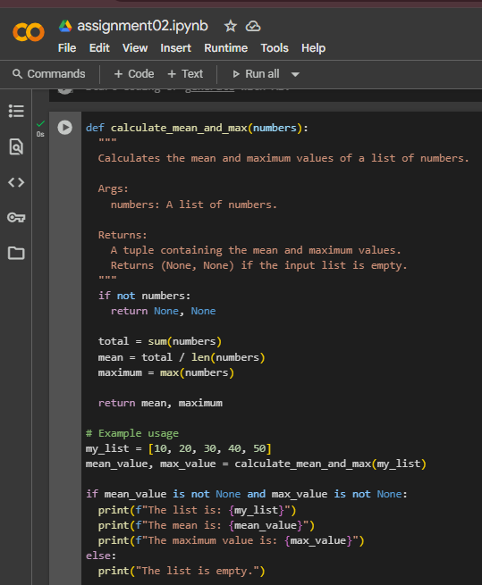
OUTPUT:
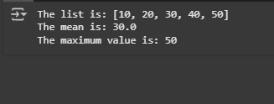

CODE EXPLANATION:
Function: calculate_mean_and_max(numbers)
- Purpose: Calculates the mean (average) and maximum values from a list of numbers.
- Empty list check: If the list is empty, returns (None, None).
- Total calculation: Uses sum(numbers) to get the total of all elements.
- Mean calculation: Divides the total by the number of elements (len(numbers)).
- Max calculation: Finds the largest number in the list using max(numbers).
- Return values: Returns both the mean and maximum as a tuple (mean, maximum).
- Creates a sample list: my_list = [10,. Calls the function: mean_value, max_value = calculate_mean_and_max(my_list)`.
- Checks if results are not None (list is not empty).
- If values exist, prints:
  - The original list.
  - The mean value.
  - The maximum value.
- If the list is empty, prints "The list is empty.".

PROMPT 02 :
I need python code ,function that checks wether a number is an amstrong number
CODE :
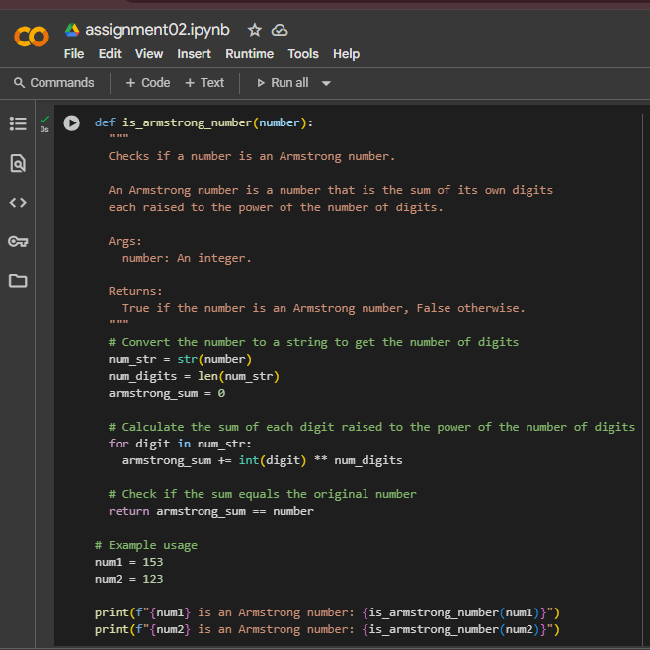
OUTPUT :
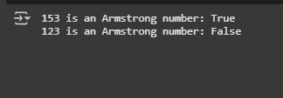
CODE EXPLANATION :
Function: is_armstrong_number(number)
- Purpose: Checks if a number is an Armstrong number.
- Convert to string: num_str = str(number) to handle digits easily.
- Get digit count: num_digits = len(num_str) stores total digits.
- Initialize sum: armstrong_sum = 0.
- Loop through digits:
  - Convert each to int.
  - Raise to num_digits power.
  - Add to armstrong_sum.
- Compare with original number:
return armstrong_sum == number → True if Armstrong, else False.
Example usage
- Checks if 153 and 123 are Armstrong numbers using the function.
- Prints results in format:
"XXX is an Armstrong number: True/False".

PROMPT 03 :
I need a python code , function check the number is prime number or a palindrome
CODE :
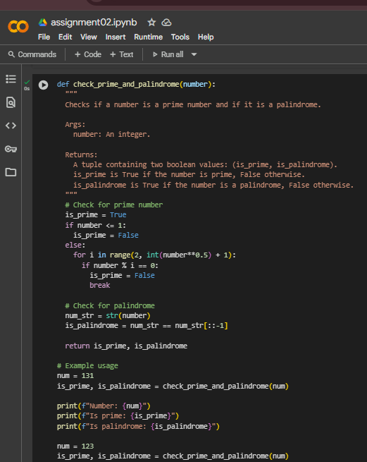
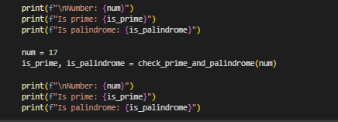
OUTPUT :
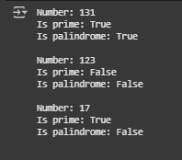
CODE EXPLANATION :
Function: check_prime_and_palindrome(number)
- Purpose: Checks if a number is prime and if it is a palindrome.
- Prime check:
  - If number ≤ 1 → Not prime.
  - Else → Check divisibility from 2 to √number.
  - If divisible → Not prime, else prime.
- Palindrome check:
  - Convert number to string: num_str = str(number).
  - Compare with reversed string: num_str[::-1].
  - If equal → palindrome.
- Return values:
  - (is_prime, is_palindrome) as a tuple of booleans.
Example usage
- Test with numbers 131, 123, and 17.
- Print:
  - The number.
  - Whether it’s prime.
  - Whether it’s a palindrome.

PROMPT 04 :
i need a pyhton code , function sum of the first N natural numbers and test the output


CODE :
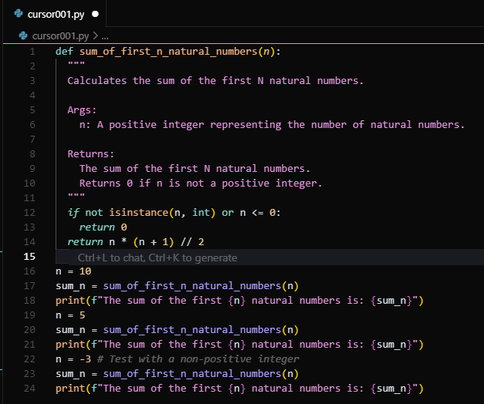
OUTPUT :
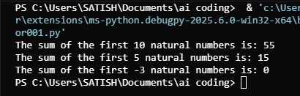
CODE EXPLANATION :
Function Purpose:
Calculates the sum of the first n natural numbers using the mathematical formula:
Sum=n(n+1)2\text{Sum} = \frac{n(n+1)}{2}Sum=2n(n+1)​
Input Validation:
Checks if the input n is a positive integer.
- If not, returns 0.
Sum Calculation:
Uses integer division (//) to compute the sum efficiently without loops.
Function Calls:
- n = 10 → Prints the sum of first 10 natural numbers.
- n = 5 → Prints the sum of first 5 natural numbers.
- n = -3 → Invalid input, so it prints 0.
Output:
Demonstrates how the function behaves for valid and invalid inputs.

PROMPT 05 :
i need a pyhton code , sum of even numbers and odd numbes
CODE :
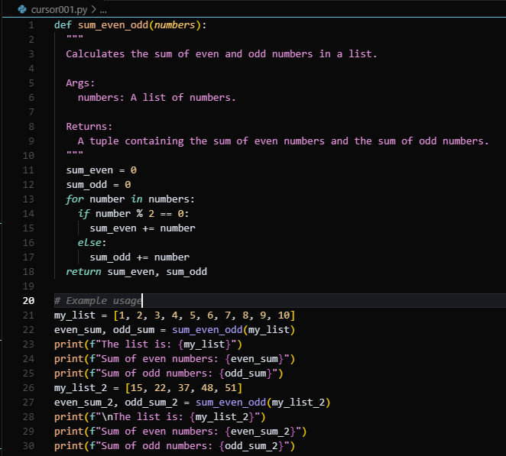
OUTPUT :
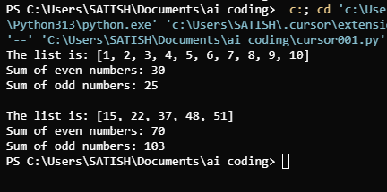
CODE EXPLANATION :
Function Purpose:
Calculates and returns the sum of even and odd numbers from a given list.
Parameters:
- numbers: A list of integers.
Initialization:
- sum_even and sum_odd are both initialized to 0.
Iteration and Condition:
- For each number in the list:
  - If the number is even (number % 2 == 0), it's added to sum_even.
  - If the number is odd, it's added to sum_odd.
Return Value:
Returns a tuple: (sum_even, sum_odd).
Example Usage:
- For my_list = [1, 2, 3, ..., 10]:
  - Even sum = 2 + 4 + 6 + 8 + 10 = 30
  - Odd sum = 1 + 3 + 5 + 7 + 9 = 25
- For my_list_2 = [15, 22, 37, 48, 51]:
  - Even sum = 22 + 48 = 70
  - Odd sum = 15 + 37 + 51 = 103
Output:
Displays the original list and the respective even and odd sums.

